Press release - REACH Incubator Open Call #1

Is your startup working with Big-Data?

Join the REACH Incubator to get up to €120K, and opportunity to work with leading corporations and their proprietary data

First REACH Incubator Open Call is ready for applications

The REACH Incubator has a €3.5 Million fund to foster the creation of data value chains across Europe and is looking for 30 promising big data startups and SMEs to take part in its first round of incubation.

REACH is an incubation programme, run by 10 core partners and 9 data providers. It will create a fertile ground for startups and SMEs to solve real-world challenges of large corporations and conduct experimentation of secured and trusted data-fuelled solutions which utilize proprietary, often multi-stakeholder, industrial and personal data.

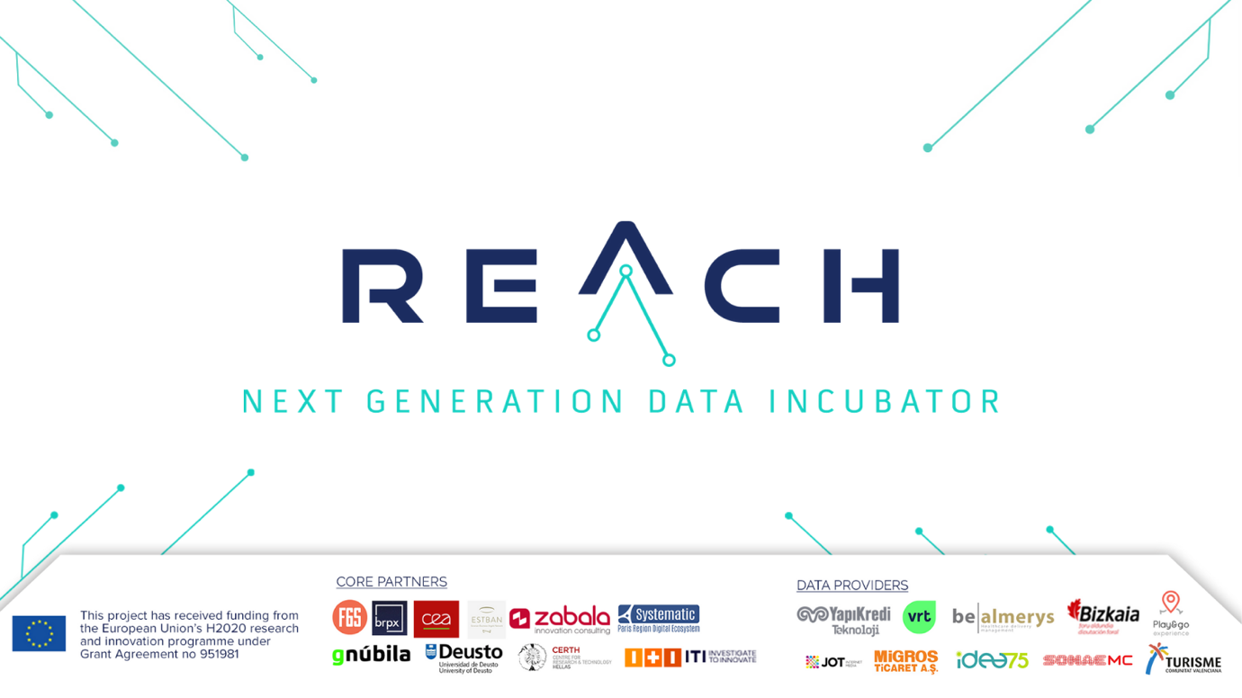

The REACH Incubator provides the following benefits:

- Up to €120,000 in Equity Free Funding
- Access to Large Corporations and their Industrial data sets
- Access to Digital and Business Skills
- REACH toolbox for secure and trusted data value chains
- Big Data Computing Infrastructure
- Access to Private Investment
- Visibility

The programme takes startups through 4 intense stages of technical and business growth (EXPLORE, EXPERIMENT, EVOLVE and EXPOSE) over eleven months, and will go through 3 incubation rounds in its three-and-a-half-year project duration. Due to Covid-19, REACH will take all the precautionary safety measures and implement its incubation services online, whenever on-site meeting and trainings are not allowed.

How does it work?
Interested startups and SMEs have three ways of applying and participating in REACH Incubator.
THEME-DRIVEN (Track 1): REACH consortium has in collaboration with the 3 leading European Digital Innovation Hubs onboard defined the cross-sectorial Data Value Chain (DVC) themes to be tackled by participants. DVC themes available in the first open call are tourism & entertainment, energy, retail, healthcare & insurance, health, manufacturing/industry.
READY-MADE (Track 2): Applications will deal with challenges defined by the REACH Data Providers according to the needs detected in their market (JOT Internet Media, Migros Ticaret A.Ş., Sonae MC, Yapı Kredi Teknoloji, De Vlaamse Radio- en Televisieomroeporganisatie nv (VRT), Play&go experience, Idea75, Almerys, Biscay Government).
FREE CHOICE (Track 3): Applicants will devise novel DVCs by bringing their own data provider/s and/or their own datasets with those already facilitated within the REACH Data Catalogue. The applicant, a single SME, will apply together with their own Data Provider/s (at least one) proposing a joint challenge to be solved.

Are you ready for open innovation opportunity? Apply here.
Deadline: February 15th, 2021 at 12:00 (noon) CET

Reserve your place at the REACH Webinar to find out more
January 26th, 13:00 CET

Follow REACH on social media:

